In the tech world, a **digital nomad** is someone who travels freely while working remotely using technology and the internet. [These individuals often have minimal material possessions and work from temporary housing, hotels, cafes, public libraries, co-working spaces, or recreational vehicles, relying on Wi-Fi, smartphones, or mobile hotspots to access the Internet1](https://en.wikipedia.org/wiki/Digital_nomad)[2](https://blog.hubspot.com/marketing/digital-nomad)[3](https://www.tourismmarketingandmanagement.com/2022/12/20/how-digital-nomads-are-shaping-the-travel-industry/).

Here are **five free learning resources** to help you explore the digital nomad lifestyle and enhance your tech skills:

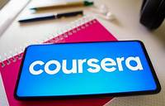

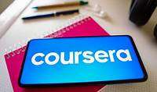

1. [**Coursera**: Offers a variety of free courses from top universities and institutions on topics such as digital marketing, remote project management, and entrepreneurship](https://en.wikipedia.org/wiki/Digital_nomad)[4](https://www.zerotough.com/free-resources-digital-nomad-institute/).
2. [**Google Digital Garage**: Provides free courses on digital marketing, data analytics, and other relevant skills](https://en.wikipedia.org/wiki/Digital_nomad)[4](https://www.zerotough.com/free-resources-digital-nomad-institute/).
3. [**HubSpot Academy**: Offers free courses on inbound marketing, content marketing, and sales](https://en.wikipedia.org/wiki/Digital_nomad)[4](https://www.zerotough.com/free-resources-digital-nomad-institute/).

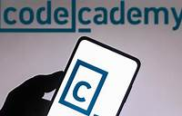

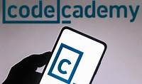

1. [**Codecademy**: Provides interactive coding lessons in various programming languages for free](https://en.wikipedia.org/wiki/Digital_nomad)[4](https://www.zerotough.com/free-resources-digital-nomad-institute/).

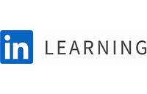

LinkedIn Learning

1. [**LinkedIn Learning**: Access a wide range of free courses related to technology, business, and creative skills](https://en.wikipedia.org/wiki/Digital_nomad)[4](https://www.zerotough.com/free-resources-digital-nomad-institute/).

Remember, these resources can empower you to embrace the digital nomad lifestyle while enhancing your tech expertise! 🌐✨